GRC102 – INFORMATION SECURITY GOVERNANCE
WEEK 4 PRACTICAL LAB REPORT
Linux Security Monitoring and Auditing
Student Name: Imelda Sanya
Registration Number: C11/26/CGRCE/17576

1. Executive Summary
This practical laboratory focused on using Linux security monitoring and auditing tools to collect technical evidence and then relate that evidence to information security governance.
The assessment was carried out on the Ubuntu Linux environment provided through the ICDFA Practice Hub. The main areas covered were Linux auditing with auditd, system and authentication log review, and a security assessment using Lynis.
The environment had some limitations that affected the audit. Although auditd was installed successfully, the assigned environment did not allow the audit subsystem to be controlled or queried normally. The system was also not running systemd as PID 1. Because of this, systemctl could not be used to manage services in the normal way. The journalctl review also returned no journal entries, while the expected /var/log/auth.log and /var/log/syslog files were not available.
These limitations are important findings themselves because security controls cannot be effectively monitored if the evidence collection mechanisms are unavailable or incomplete.
Lynis provided more detailed security assessment results. The scan was completed using Lynis 3.0.9 and performed 232 tests. The resulting hardening index was 62. Three warnings were reported: vulnerable packages, insufficient responsive nameservers, and the absence of klogd. Lynis also generated 43 suggestions.
From a governance perspective, the main concern identified during the laboratory was the availability and reliability of security monitoring evidence. Patch management, DNS resilience and system logging were also identified as areas requiring attention.

2. Scope and Authorisation
The assessment was performed only against the Linux system assigned through the ICDFA Ubuntu Practice Hub.
No external systems, production systems or unauthorised devices were targeted.
The assessment covered:
- Installation and verification of auditd
- Attempted audit rule verification
- Linux audit evidence collection
- journalctl log review
- Authentication and privilege-use log review
- General system log review
- Lynis installation and security assessment
- Identification of security weaknessesGovernance and control-monitoring analysis
Conceptual mapping of Linux evidence to SIEM and continuous monitoring

3. Methodology

3.1 Linux auditing
First, I checked whether the Linux auditing tools were available. auditd, auditctl, ausearch and aureport were not initially available, so the approved Ubuntu package installation method was used to install auditd and audispd-plugins.
The installation was successful.
However, the environment presented a limitation when trying to operate the audit subsystem. The system did not provide the required audit control capabilities, meaning that auditctl could not be used to retrieve or modify the audit rule set.
The normal service-management approach was also not available because systemd was not running as PID 1.
Rather than treating these failures as successful audit evidence, they were recorded as environment limitations.

3.2 Linux log review
The second stage involved checking the system journal and traditional Linux security logs.
The following areas were reviewed:
- Journalctl
- /var/log/auth.log
- /var/log/syslog
- /var/log/audit
- Other available files under /var/log
The system returned no journal entries through journalctl. The expected auth.log and syslog files were also not present.
This meant that there was insufficient authentication and system-log evidence available from the assigned environment to identify normal failed-login or privilege-use events.

3.3 Lynis security assessment
The third stage used Lynis to assess the security configuration of the Linux system.
Lynis version 3.0.9 was installed and the following command was used:
sudo lynis audit system
The scan completed and produced a security assessment containing warnings, suggestions and a hardening index.
The Lynis report and log locations were also recorded:
- /var/log/lynis.log
- /var/log/lynis-report.dat

4. Findings – Auditd Configuration and Monitoring
auditd was installed successfully in the assigned environment.
However, the audit subsystem could not be controlled or queried normally. Attempts to use auditctl returned an operation-not-permitted response, even when using sudo.
The environment also did not use systemd as PID 1. Consequently, the normal systemctl service-management process could not be used.
This means that I could confirm the presence and installation of the audit tooling, but I could not provide valid evidence showing a successfully loaded custom audit rule set or generated ausearch records.
I have therefore treated this as a monitoring coverage limitation rather than inventing audit events or rule output.
Governance significance
Audit logging is an important source of evidence for privileged activity, account changes and other security-relevant actions. If audit coverage cannot be verified, there is a risk that security events may occur without sufficient evidence for investigation or assurance.
Recommended action
- For a production Linux system, the audit service and its rules should be managed through an approved configuration process. The organisation should verify that:
audit rules are loaded;
audit events are being generated;
audit logs are retained;
security teams can query the records; and
the audit configuration is periodically reviewed.
The control should then be retested by verifying the loaded rules and retrieving known benign audit events.

5. Linux Log Analysis
The log review showed another important limitation.
Running:
sudo journalctl --since "today" --no-pager
returned:
No journal files were found. -- No entries --
The expected authentication log, /var/log/auth.log, was not present.
The expected system log, /var/log/syslog, was also not present.
The /var/log directory contained other files, including package-management and system-related logs, but these did not provide equivalent authentication-event evidence.
Interpretation
I could not identify a genuine failed login, successful login or privilege-use event from the expected authentication logs because the relevant logging sources were unavailable.
This is different from saying that no authentication events occurred. The correct conclusion is that the available evidence did not allow those events to be verified.
Governance significance
A security control cannot be effectively monitored if its evidence source is missing or unavailable. Management may believe that authentication monitoring exists, but without retained and accessible evidence, the effectiveness of the control is difficult to demonstrate.
Recommended action
- The organisation should define an approved logging architecture for Linux systems and confirm:
which logging service is responsible;
which authentication events are collected;
how long logs are retained;
who can access them;
whether logs are forwarded centrally; and
how missing or failed logging is detected.

5.1 Security Event / Condition Findings Table
The following table records the security-relevant conditions that could be established from the available evidence. Where a normal log source was unavailable, the table records the evidence limitation rather than assuming that an event did or did not occur.
Event / Condition | Evidence Source | Time | User / Service | Security Significance | Recommended Action
No journal entries available | journalctl --since "today" | 27 Sep 2026 | System journal | Recent journal evidence could not be reviewed for security events. | Establish and verify an approved journal/logging configuration.
Authentication log unavailable | /var/log/auth.log check | 27 Sep 2026 | Authentication logging | Authentication and privilege-use activity could not be independently reviewed from the expected log. | Configure an approved authentication logging source and retention process.
System log unavailable | /var/log/syslog check | 27 Sep 2026 | System logging | Expected system error/warning evidence was not available through syslog. | Establish the approved system logging source and verify error/warning collection.
Audit log directory contained no event files | /var/log/audit review | 27 Sep 2026 | auditd / audit logging | Audit records could not be verified from the expected audit log location. | Confirm audit collection is functioning and that records are retained and queryable.
Lynis kernel logging warning | Lynis LOGG-2138 | 27 Sep 2026 | klogd / logging | Lynis reported that klogd was not running, creating a potential gap in kernel-message logging. | Implement the approved logging architecture and verify kernel/system events are captured.

6. Lynis Security Assessment
The Lynis assessment provided the most complete set of security findings from the laboratory.
- The scan identified:
Lynis version: 3.0.9
Operating system: Ubuntu 24.04
Kernel: 7.0.0
Tests performed: 232
Hardening index: 62
Warnings: 3
Suggestions: 43
The report also showed that the firewall was detected, while a malware scanner was not found.
The three warnings were selected for detailed analysis.

6.1 Finding 1 – Vulnerable Packages
Lynis ID: PKGS-7392
Lynis reported: “Found one or more vulnerable packages.”
Risk
Vulnerable software packages can contain known weaknesses that could be exploited if they remain unpatched.
Control affected
Patch management and vulnerability management.
Evidence
The Lynis 3.0.9 scan generated warning PKGS-7392.
Likely owner
System Administrator / Infrastructure Team / Security Operations.
Recommended remediation
The affected packages should be identified and reviewed. Approved security updates should then be applied through the organisation's normal patch-management process.
Priority
High
Retest
After approved updates are applied, the system should be rescanned using Lynis and the package vulnerability status should be checked again.

7. Finding 2 – Insufficient Responsive Nameservers
Lynis ID: NETW-2705
Lynis reported: “Couldn't find 2 responsive nameservers.”
The scan showed that 127.0.0.11 was responsive, but the test still generated a warning because two responsive nameservers were not identified.
Risk
If only one usable DNS resolver is available, DNS resolution may become a single point of failure. This could affect the availability of services that depend on name resolution.
Control affected
Network availability and resilience.
Evidence
Lynis generated warning NETW-2705.
Likely owner
Network Administrator / Infrastructure Team.
Recommended remediation
The DNS configuration should be reviewed. Where appropriate, an approved secondary or backup DNS resolver should be configured.
Priority
Medium
Retest
The DNS configuration should be tested and the Lynis assessment repeated to confirm that the required responsive nameserver condition is satisfied.

8. Finding 3 – Kernel Logging
Lynis ID: LOGG-2138
Lynis reported: “klogd is not running, which could lead to missing kernel messages in log files.”
The logging section of the scan also reported a warning for the absence of a running log daemon. It did not identify Syslog-NG, systemd journal, RSyslog or several other listed logging mechanisms.
Risk
Important kernel or system events may not be available for security monitoring and investigation if the appropriate logging mechanism is not operating.
Control affected
Security logging and monitoring.
Evidence
Lynis generated warning LOGG-2138.
This finding also aligns with the earlier laboratory observation that the journal contained no entries and that the expected authentication and system log files were unavailable.
Likely owner
System Administrator / Security Operations Team.
Recommended remediation
The organisation should first establish which logging architecture is intended for the Linux system. An approved logging service should then be configured to collect the required kernel and security events.
Logs should also be retained and, where required, forwarded to a central monitoring platform.
Priority
High
Retest
Verify that the approved logging service is running, generate a benign test event where appropriate, confirm that the event is recorded, and rerun the relevant Lynis checks.

9. Control-Monitoring and Governance Table

10. Governance Issues Requiring Attention
10.1 Security monitoring evidence is incomplete
The inability to access the Linux audit subsystem and the absence of expected journal/authentication logs make it difficult to demonstrate that monitoring controls are operating effectively.
This should be treated as a control-assurance issue rather than simply a technical inconvenience.
10.2 Patch management requires follow-up
Lynis identified vulnerable packages through PKGS-7392. This should be reviewed by the infrastructure or vulnerability-management function and handled according to the organisation's patching process.
10.3 Logging coverage requires attention
The Lynis logging findings, together with the lack of available journal and traditional authentication/system logs, indicate that logging coverage needs to be reviewed.
A governance process should define the minimum logging requirements and the evidence that must be retained.

11. SIEM and Continuous Monitoring Mapping
The laboratory does not require deployment of an actual SIEM. The objective is to explain how the Linux evidence could be integrated into enterprise monitoring.
A possible monitoring flow would be:
Structured SIEM / Continuous Monitoring Mapping
Linux Evidence Source | Condition / Trigger | SIEM or Monitoring Action | Operational Alert? | Governance Escalation?
Linux evidence source | Condition / trigger | SIEM or monitoring action | Operational alert | Governance escalation
auditd / audit subsystem | Audit rules unavailable or audit events cannot be queried | Monitor audit-agent health and audit-data availability | Yes — monitoring/collection failure | Yes if audit coverage remains unavailable or violates control requirements
Authentication logs | Repeated failed logins or unusual privileged activity | Collect, normalize and correlate authentication events | Yes — SOC/security alert | Escalate when thresholds indicate a control breach or repeated pattern
System journal / syslog | Repeated errors, warnings or loss of logging service | Detect logging failures and correlate system events | Yes — operational/security alert | Escalate if logging outage exceeds the approved threshold
Lynis vulnerability findings | Vulnerable packages identified by PKGS-7392 | Feed vulnerability status into vulnerability-management tracking | Usually — ticket/workflow rather than immediate incident alert | Yes when remediation is overdue or risk exceeds the approved threshold
DNS resilience finding | Insufficient responsive nameservers (NETW-2705) | Monitor resolver availability and configuration drift | Yes if resolver availability fails | Escalate if resilience remains below the control requirement
Kernel logging finding | klogd not running / LOGG-2138 | Monitor logging-service health and event-ingestion continuity | Yes — logging health alert | Escalate if the logging control remains ineffective or evidence retention is affected
The distinction is based on the nature of the condition: individual technical events can remain operational alerts, while persistent loss of audit/logging coverage, overdue vulnerability remediation or failure to meet an approved control threshold should enter the governance or control-assurance process.
Linux Host
↓
Auditd / System Logs / Authentication Logs
↓
Log Collector / Agent
↓
SIEM
↓
Normalisation and Correlation
↓
Security Alert
↓
SOC Investigation
↓
Incident / Control-Assurance Workflow
For example, an authentication monitoring rule could identify repeated failed login attempts. A privileged-access rule could identify unusual use of administrative commands. A vulnerability-management integration could identify systems with unresolved vulnerable packages.
Not every SIEM alert needs to become a governance issue.
A single failed login may remain a normal operational security event. However, repeated failed logins, persistent logging failures, unresolved critical vulnerabilities or prolonged absence of audit evidence may need escalation because they indicate that an approved security control may not be operating effectively.

12. Remediation and Retest Plan

13. Evidence Limitations
One of the main lessons from this laboratory was that running a security command does not automatically mean that useful security evidence exists.
The assigned environment had several technical limitations.
First, although auditd was installed, the kernel audit interface could not be controlled or queried normally.
Second, the system was not running systemd as PID 1, which prevented normal use of systemctl.
Third, journalctl returned no journal entries.
Fourth, /var/log/auth.log and /var/log/syslog were not available.
These limitations were recorded rather than replaced with fabricated events.
This is particularly important because the laboratory instructions require command output, screenshots and log evidence to come from the authorised environment and explicitly prohibit fabrication of security events or timestamps.

14. Conclusion
This laboratory demonstrated the relationship between technical security evidence and information security governance.
The Linux environment provided useful evidence through the installation records and Lynis security assessment, but it also demonstrated the challenges that arise when security monitoring infrastructure is incomplete or restricted.
The Lynis scan produced a hardening index of 62 after 232 tests and identified three warnings relating to vulnerable packages, DNS resilience and kernel logging.
The audit and log review also showed that evidence availability itself needs to be treated as a security control. If audit records, authentication logs or system logs cannot be accessed, it becomes difficult for security teams and auditors to determine what has happened on a system.
The recommended next steps are therefore to improve audit and logging coverage, review the vulnerable-package finding, address the DNS resilience issue where appropriate, and establish a clear process for retesting the controls after remediation.
Overall, the exercise showed that security monitoring is not only about collecting logs. The evidence needs to be available, reliable, reviewed and connected to defined control owners and remediation processes. This is what allows technical security information to support governance and assurance decisions.

15. Appendix A – Evidence Index

16. Appendix B – Key Lynis Results
Lynis Version: 3.0.9
Operating System: Ubuntu 24.04
Kernel: 7.0.0
Tests Performed: 232
Hardening Index: 62
Warnings: 3
Suggestions: 43
Warnings
1. PKGS-7392 – One or more vulnerable packages
2. NETW-2705 – Fewer than two responsive nameservers
3. LOGG-2138 – klogd not running
- Selected Suggestions
LOGG-2130 – Check whether a syslog daemon is running and correctly configured
ACCT-9628 – Enable auditd to collect audit information
FINT-4350 – Install a file integrity tool
HRDN-7230 – Consider installing a malware scanner

17. AI Assistance Declaration
AI tools were used to assist with organising the report structure, explaining technical concepts and improving the clarity of the written discussion. All practical commands, screenshots and security findings were obtained from the authorised ICDFA laboratory environment and were reviewed before being included in this report.
Control / Objective | Evidence | Owner |  | Status | KPI / KRI / Threshold | Risk / Significance |  | Remediation | Retest / Follow-up
Audit logging | auditd installed but audit control/query operations restricted | System Administrator / Security Operations |  | Limited | Audit rules must be loaded and queryable | Inability to verify audit events reduces monitoring and investigation capability |  | Confirm supported audit configuration and ensure audit events can be queried | Verify rules with auditctl and retrieve test events
Authentication logging | journalctl returned no entries; auth.log unavailable | System Administrator / SOC |  | Insufficient evidence | Authentication events should be available and retained | Failed or successful authentication activity may not be available for investigation |  | Configure and verify approved authentication logging | Generate/observe benign authentication event and verify recording
System/security logging | syslog unavailable; Lynis identified logging warning | System Administrator / SOC |  | Needs attention | Required system/security logs should be continuously available | Missing logs reduce visibility into system and security events |  | Establish approved logging service and retention configuration | Verify log generation and rerun logging checks
Vulnerability management | Lynis warning PKGS-7392 | Infrastructure / Security |  | Warning | Vulnerable packages should be remediated within defined SLA | Known software weaknesses may remain exploitable |  | Review and patch affected packages | Run package checks and Lynis again
DNS resilience | Lynis warning NETW-2705 | Network / Infrastructure |  | Warning | At least two approved responsive DNS resolvers where required | Single resolver dependency can affect service availability |  | Review DNS configuration and add approved secondary resolver where appropriate | Test DNS resolution and rerun Lynis
Kernel logging | Lynis warning LOGG-2138 | System Administrator / SOC |  | Warning | Required kernel/security events should be logged | Missing kernel messages may reduce investigation evidence |  | Configure approved kernel/system logging | Verify generated events appear in logs
Finding |  | Proposed Action |  |  | Owner |  |  | Retest
Auditd coverage limitation |  | Confirm supported audit configuration and ensure audit events are being collected |  |  | System Administrator |  |  | Verify loaded rules and retrieve audit records
Missing authentication/system logs |  | Establish approved logging and retention configuration |  |  | System Administrator / SOC |  |  | Confirm new events are recorded
Vulnerable packages |  | Review affected packages and apply approved security updates |  |  | Infrastructure Team |  |  | Run vulnerability/package checks and Lynis again
DNS nameserver warning |  | Review DNS configuration and provide approved secondary resolver where required |  |  | Network Team |  |  | Test resolver availability and rerun Lynis
Kernel logging |  | Establish appropriate kernel/system logging mechanism |  |  | System Administrator / SOC |  |  | Verify kernel/system events are captured
File integrity monitoring |  | Consider deployment of an approved file-integrity monitoring tool |  |  | Security Team |  |  | Generate approved test file change and verify alert
Evidence ID |  |  | Evidence |  |  |  | Suggested Filename
E01 |  |  | Auditd installation and audit subsystem access limitation |  |  |  | auditd Installation and Audit Subsystem Access Limitation.png
E02 |  |  | Journal review – no journal files/entries |  |  |  | 02_Journalctl_No_Journal_Files.png
E03 |  |  | Authentication log unavailable |  |  |  | 03_Authentication_Log_Not_Available.png
E04 |  |  | System log unavailable |  |  |  | 03_System_Log_Not_Available.png
E05 |  |  | Audit, journal and bootstrap log review |  |  |  | 04_Audit_Journal_and_Bootstrap_Logs.png
E06 |  |  | Available log sources under /var/log |  |  |  | 04_Available_Log_Sources.png
E07 |  |  | Auditd installation log |  |  |  | 05_Auditd_Installation_Log.png
E08 |  |  | DPKG auditd installation evidence |  |  |  | 06_DPKG_Auditd_Installation.png
E09 |  |  | Lynis version 3.0.9 |  |  |  | 07_Lynis_Version.png
E10 |  |  | Lynis security scan summary |  |  |  | 08_Lynis_Security_Scan_Summary.png

18. Appendix C – Supporting Evidence Screenshots
The following screenshots are included as supporting evidence from the authorised ICDFA Ubuntu Practice Hub lab. They document the commands executed, the available logging sources, the auditd installation, and the Lynis assessment results. No screenshot has been used to imply an event that was not actually observed.
Evidence E01 – Auditd installation and audit subsystem access limitation
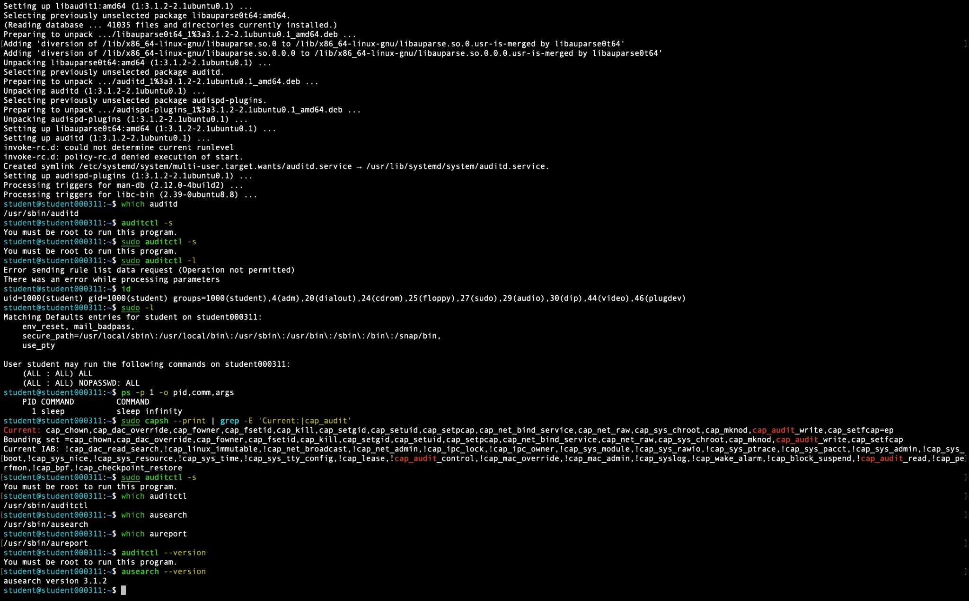

Evidence E02 – journalctl returned no journal files or entries


Evidence E03 – /var/log/auth.log was not available

Evidence E04 – /var/log/syslog was not available
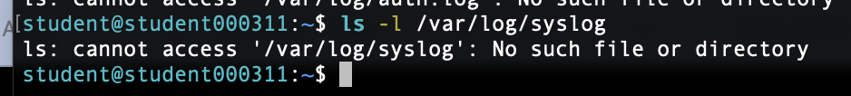

Evidence E05 – audit, journal and bootstrap log review
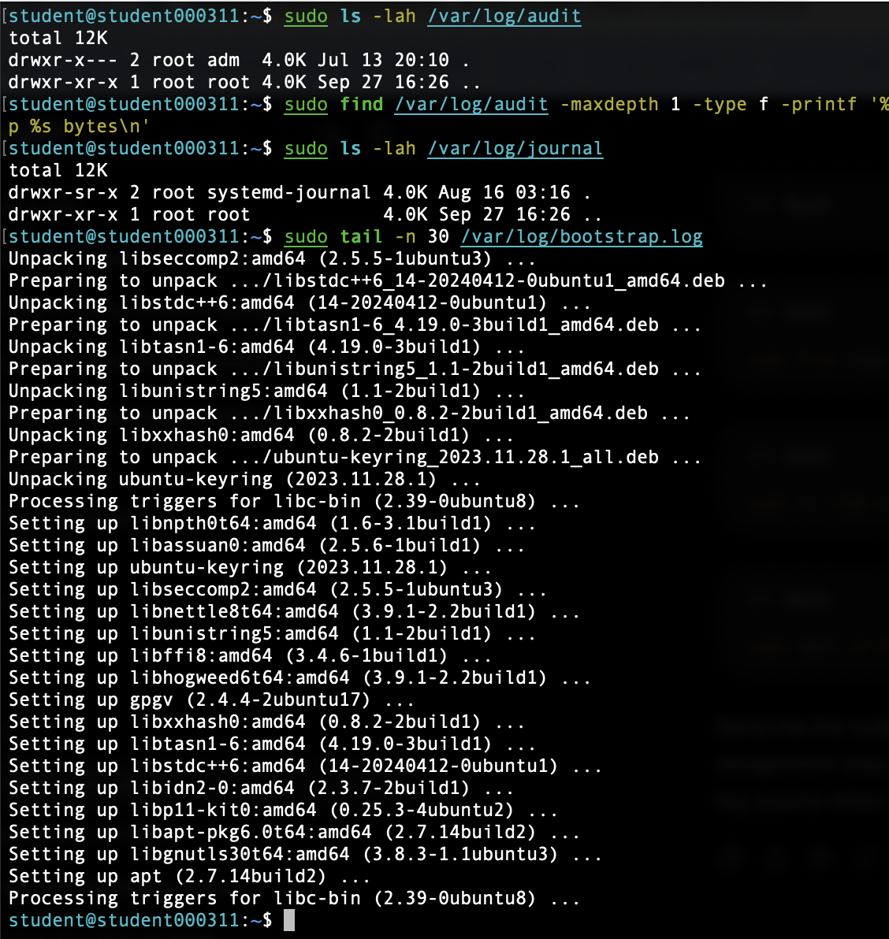

Evidence E06 – available log sources under /var/log
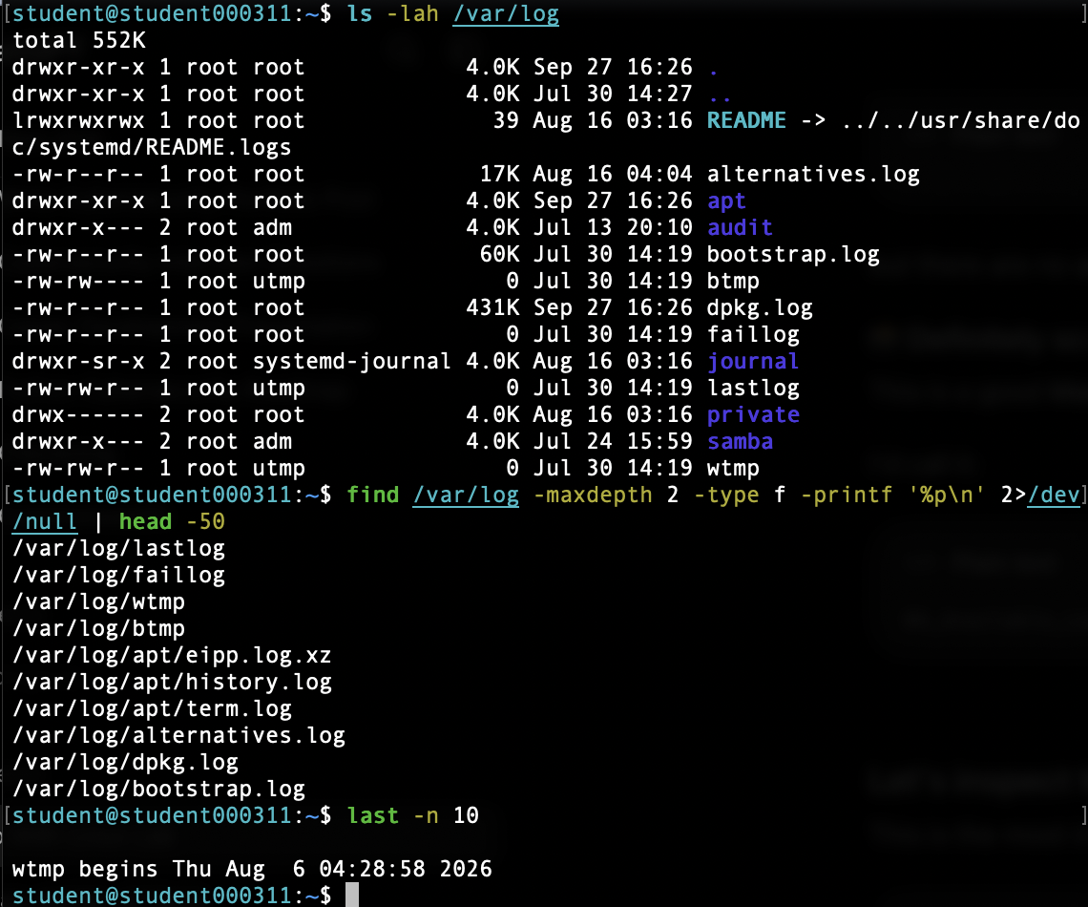

Evidence E07 – auditd installation log
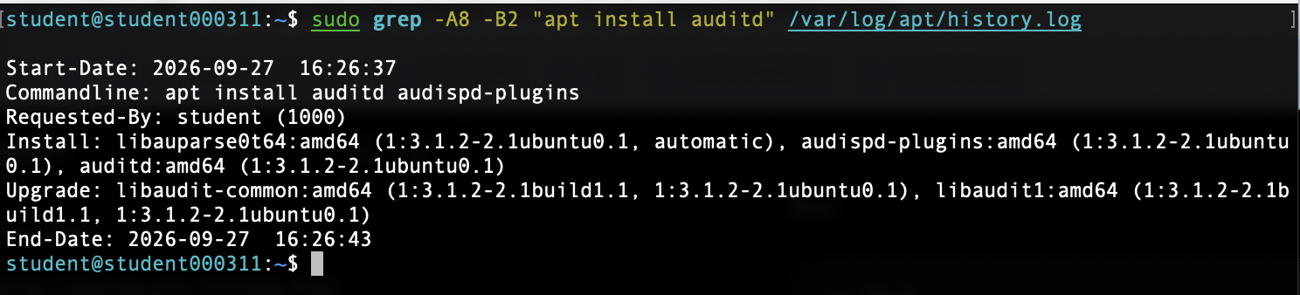

Evidence E08 – DPKG evidence confirming auditd installation
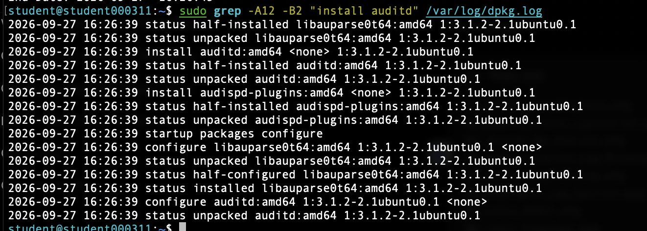

Evidence E09 – Lynis version 3.0.9


Evidence E10 – Lynis security scan summary
